Roy Meyers' Absorber -- "Free Energy"
by Robert A. Nelson
As planet Earth suffers under the relentless onslaught of ever increasing human consumption, we are becoming increasingly desperate for sources of energy with which to power our pretensions of civilization. There is not enough oil or coal available to sustain the present rate of growth, and the apparently inevitable result will be endless wars over dwindling resources. There are, however, numerous marvelous alternative energy technologies that have been suppressed by the powers that be.
We could easily be enjoying the benefits of clean, cheap (and even free) energy in various forms, were it not for the insatiable greed of our corporate masters, who rule the world without regard for humanity or the environment.
There are dozens of stories that can be told of inventors who presented wonderful liberating technologies, only to be ruined for their efforts. Many people have heard of various types of so-called "free energy" or "over-unity" generators that tap what scientists call Zero Point Energy (and other names, such as the aether) without need for fuel and without producing any pollution. Detractors like to label such devices as impossible "perpetual motion machines", even though some of them are solid state electronic systems that have been built and shown to work. Readers who are interested in such possibilities need search no farther than the impeccable history of Thomas Henry Moray, which is widely published on the internet (e.g., http://www.rexresearch.com/moray.moray.htm).
If that is too much bother for you, then just continue reading here. This is the little-known story of Roy Jerome Meyers, who invented an "Absorber" that produced limitless electrical power from the terrestrial magnetic field.
Almost 100 years ago, Meyers served a 3-1/2 year sentence in the Arizona state prison at Florence. Before his incarceration, he had already invented an improved trolley wheel head that prevented it from jumping off the wire. While he was imprisoned, he was inspired to invent a device that would draw electricity from the atmosphere. He conferred with Superintendent Sims and Parole Clerk Sanders, and convinced them to give him the opportunity to develop his idea in a wooden shed on the grounds of the penitentiary. Within a few weeks, using easily available materials (chrome steel magnets and iron wire), he constructed the first crude working model, and used it to spark the gas engines of the prison's pump house. His second model developed 8 volts.
Miss Kate Barnard, who was State Commissioner of Charities and Corrections of Oklahoma, was a guest of Superintendent Sims at the time, and she saw the machine in operation. Miss Barnard was so impressed by it and by Meyers' essential integrity (despite the lapse that had gotten him imprisoned) that she told the story of Roy Meyers when later she appeared before the Arizona legislature to address them concerning prison reform. The legislature and Governor Hunt were convinced to grant Meyers an unsupervised leave of absence for 30 days to travel to Washington DC in order to apply for a patent.
Meyers gave this account of his trip:
"When I arrived in Washington and laid my plans before the patent office experts, they merely smiled and told me that I would have to build a model and demonstrate my claims --- that it seemed strange that I, unknown as I am in the electrical world, should have accomplished the things for which Edison, Tesla and other experts have been striving for years.
"They could not grasp the meaning of my drawings nor the explanation I tried to make to them. There was little time to spare, as I had only 20 days left of my leave, but I set to work in a few days was able to take a crude model around to the patent office to make a demonstration.
"Arriving at the patent office I telephoned to a friend who had been so kind as to introduce me and aid me in reaching the proper officials. The absorber was hoisted on two short poles and made to work. While they were as yet unable to understand the principles involved and hardly willing to believe their eyes, they were forced to admit that I had something new and different, and they told me that there would be no further objection; that I might file my application without further delay.
"I hope to construct my first large machine right here in Phoenix. I feel grateful; to Governor Hunt and others for what they have done for me and to the help they have given in securing protection I might not otherwise have had, and I am desirous of demonstrating this gratitude. I am going back to Florence today to resume the serving of my sentence, which will expire in 10 months. Then, here in Phoenix, I will begin the work of making my machines." (Technology World Magazine, 1912)
Meyers planned to build a 200 foot tower upon which to place an "Absorber" (as he called it) with sufficient power to light the city of Phoenix. According to him, it comprised "a series of magnetized steel plates set in a circle and this mechanism attracts the electricity from the atmosphere. This is carried by wires to a transformer in the engine house below and thence is applied to produce either power or light after the usual manner.
"The flow of electricity is constant. When it emerges into the transformer it is in the form of a direct current. It will absorb the electricity day and night and will work whenever the wireless will work. I can put up a plant to supply such a building as the Adams Hotel for about $1500, and one of the principal items of the expense is the cost of the towers, the wires, the magnetizing of one set of plates, which is part of the secret of the treatment which makes it respond to the accumulations of the atmosphere.
"For use in the case of an electrical storm I have made what I call a modified form of circuit breaker, such as is commonly used as a lightning arrester on telegraph lines. In case of a storm the accumulator would suddenly become overcharged, possibly, and as the electricity would not of itself flow back into the air, the result might be disastrous. So I send it down into the ground, whenever the voltage rises above a certain amount."
And the story ends there. It is not known what became of Roy J. Meyers. No "Absorber" was built to power Phoenix, and it appears that a US Patent was not granted. This writer first learned of Meyers' Absorber in 1986, and repeatedly searched for it in the US Patent Gazette, to no avail. It was not until 2006 that Meyers' British patent for "Improvements in and Relating to Apparatus for Producing Electricity" was located after several periodic advanced searches of the European Patent Office online (http://ep.espacenet.com). The patent has long since expired and entered the public domain. It is reprinted below for your edification.
It should be obvious from this brief but indisputable account, and the description given in the patent, that "free energy" is a reality. Anyone who thinks otherwise is merely ignorant or in denial.
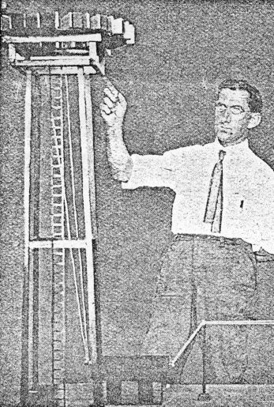
Roy J. Meyers & the "Absorber"
References
(1) Charlton Lawrence Edholm: "Picks Power from the Air"; Technology World Magazine, p. 279-281 (1912)Electronic World (November 1912)
(2) Roy Jerome Meyers: British Patent # 1098 (January 14, 1913); Improvements in and Relating to Apparatus for Producing Electricity
British Patent # 1098
(January 14, 1913)
Improvements in and Relating to Apparatus for Producing Electricity
Roy Jerome Meyers
This invention relates to improvements in apparatus for the production of electrical currents, and the primary object in view is the production of a commercially serviceable electrical current without the employment of mechanical or chemical action. To this end the invention comprises means for producing what I believe to be dynamic electricity from the earth and its ambient elements.
I am, of course aware that it has been proposed to obtain static charges from upper strata of the atmosphere, but such charges are recognized as of widely variant potential and have thus far proved of no practical commercial value, and the present invention is distinguished from all such apparatus as has heretofore been employed for attracting static charges by the fact that this improved apparatus is not designed or employed to produce or generate irregular, fluctuating or other electrical charges which lack constancy, but on the other hand I have by actual test been able to produce from a very small apparatus at comparatively low elevation, say about 50 or 60 feet above the earth’s surface, a substantially constant current at a commercially usable voltage and amperage. This current I ascertained by repeated tests is capable of being readily increased by additions of the unit elements in the apparatus hereinafter set forth, and I am convinced from the constancy of the current obtained and its comparatively low potential that the current is dynamic and not static, although, of course, it is not impossible that certain static discharges occur and, in fact, I have found occasion to provide against the damage which might result from such discharge by the provision of lightning arresters and cut-out apparatus which assist in rendering the obtained current stable by eliminating sudden fluctuations which sometimes occur during conditions of high humidity from what I consider static discharges. The nature of my invention is obviously such that I have been unable to establish authoritatively all of the principles involved, and some of the theories herein expressed may possibly prove erroneous, but I do know and am able to demonstrate that the apparatus which I have discovered does produce, generate, or otherwise acquire a difference of potential representing a current amperage above stated, or varied therefrom at the will of the operator according to the uses which the current is to be subjected.
The invention comprises generically means for producing electrical currents of serviceable potential substantially without the employment of mechanical or chemical action, and in this connection I have been able to observe no chemical action whatever on the parts utilized although deterioration may possibly occur in some of the parts, but so far as I am able to determine such deterioration does not add to the current supply but is merely incidental to the effect of climatic action.
The invention more specifically comprises the employment of a magnet or magnets and a co-operating element, such as zinc disposed adjacent to the magnet or magnets and connected in such manner and arranged relative to the earth so as to produce current, my observation being that current is produced only when such magnets have their poles facing substantially to the north and south and the zincs are disposed substantially along the magnets.
The invention also comprehends other details of construction, combinations and arrangements of parts as will hereinafter be fully set forth and claimed.
In the accompanying drawings:
Figure 1 is a top plan view of an apparatus embodying the features of the present invention, the arrow accompanying the figure indicating substantially the geographical north, parts of the figure being diagrammatic for condensing the showing.
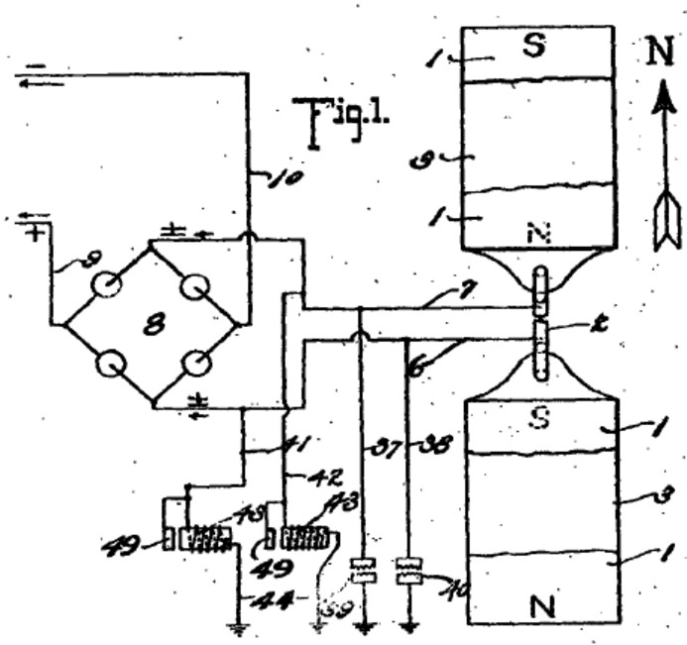
Figure 2 is a view is side elevation of the parts seen in plan in Figure 1.
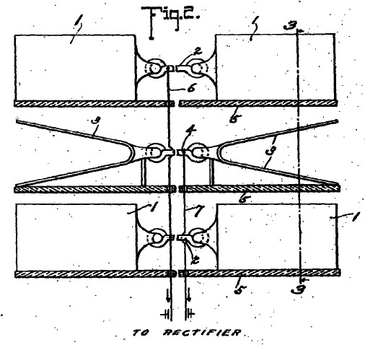
Figure 3 is a vertical section taken on the plane indicated by the line 3-3 of Figure 2 and looking in the direction indicated by the arrow.
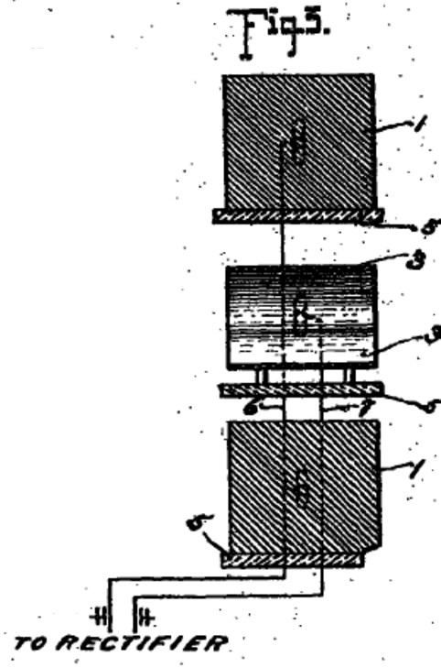
Figure 4 is a detail view partly in elevation and partly in section showing the detail connections of the converter and intensifier.
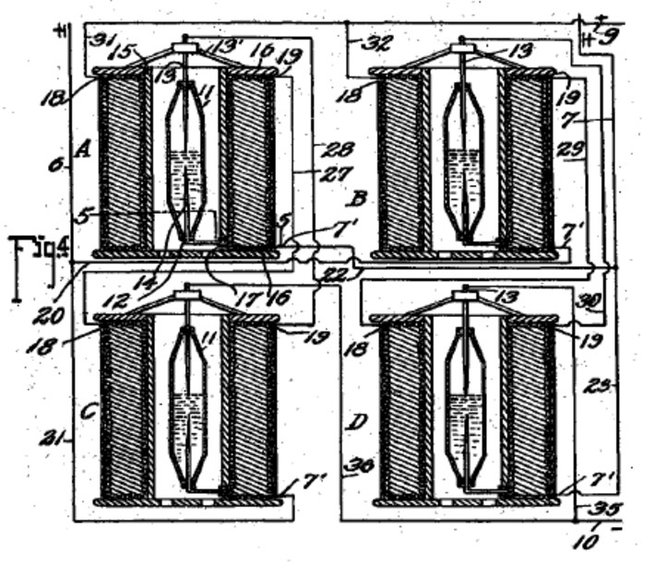
Figure 5 is a transverse section taken on the planes indicated by line 5-5 of Figure 4 and looking downwardly.
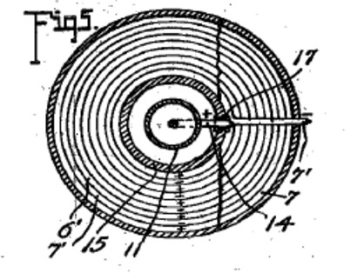
Figure 6 is an enlarged detail fragmentary section illustrating the parts at the juncture of the conductors and one of the intensifiers.
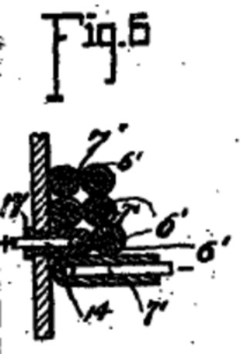
Figure 7 is an enlarged detail view partly in elevation and partly in section of one of the automatic cut-outs and
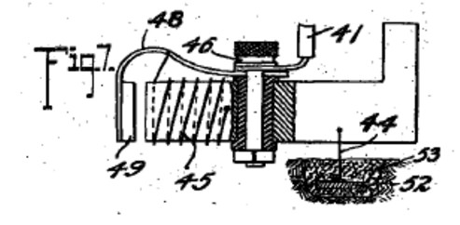
Figure 8 is a diagrammatic view of one of the simplest forms of embodiment of the invention.
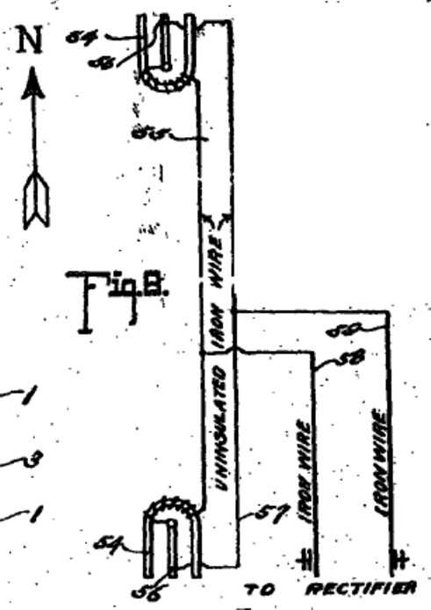
Referring to the drawing by numerals, 1,1 indicates magnets connected by a magnetic substance 2, preferably an iron wire. The magnets 1 are arranged in pairs, one pair being spaced beneath the other, and interposed between the magnets are zinc plates 3,3 connected by an iron wire conductor 4. Suitable insulating supports 5 are arranged for sustaining the respective magnets 1 and plates 3,3. Each plate 3 is preferably bent substantially into V form, as clearly seen in Figure 1, and the V1 of one of the plates opens or faces toward the north and the V of the other plate to the South. I have determined by experimentation that it is essential that the plates 3 be disposed substantially north and south with their flat faces approximately parallel to the adjacent faces of the co-operating magnets, although by experience I have not discovered any material difference in the current obtained when the plates are disposed slightly to one side of north and south, as for instance when the plates are disposed slightly to one side of north and south, as for instance when disposed in the line of the magnetic polarity of the earth. The same is true with respect to the magnets 1, the said magnets being disposed substantially north and south for operative purposes, although I find that it is immaterial whether the north pole of one of the magnets is disposed to the north and the south pole to the south, or vice versa, and it is my conviction from experience that it is essential to have the magnets of each pair connected by magnetic material so that the magnets substantially become one with a pole exposed to the north and a pole exposed to the north. In Figure 1, I have indicated in full lines by the letters 8 and N the respective polarities of the magnets 1, and have indicated in dotted lines the other pole of those magnets when the connection 2 is severed. I have found that the magnets and zinc plates operate to produce, whether by collection or generation I am not certain, electrical currents when disposed substantially north and south, but when disposed substantially east and west no such currents are produced. I also find that the question of elevation is by no means vital, but it is true that more efficient results are obtained by placing the zincs and magnets on elevated supports. I furthermore find from tests that it is possible to obtain currents from the apparatus with the zincs and magnets disposed in a building or otherwise enclosed, although more efficient results are obtained by having the said elements arranged in the open.
While in Figures 1, 2, and 3, I have shown the magnets and the zinc plates as superimposed, it will be apparent, as hereinafter fully set forth, that these elements may be juxtaposed in horizontal planes, and substantially the same results will be secured. Furthermore, the magnets 1 with the interposed zincs 3, as shown in Figures 1, 2 and 3 merely represent a unit which may be repeated either horizontally or vertically for increasing the current supply, and when the unit is repeated the zinc plates are arranged alternating with the magnets throughout the entire series as hereinafter indicated.
A conductor 6 is connected in multiple with the conductors 2 and a conductor 7 is connected with conductor 4, the conductor 6 extending to one terminal of a rectifier which I have indicated by the general reference character 8, and the conductor 7 extending to the other terminal of said rectifier. The rectifier as seen in diagram in Figure 1 may assume any of several well known embodiments of the electrical valve type and may consist of four asymmetric cells or Cooper-Hewitt mercury vapor lamps connected as indicated in Figure 1 for permitting communication of the positive impulses from the conductor 6 only to the line conductor 9 and the negative impulses from conductor 6 on only to the line conductor 10. The current from this rectifier may be delivered through the conductors 9 and 10 to any suitable source for consumption.
While the said rectifier 8 may consist of any of the known types, as above outlined, it preferably consists of a specially constructed rectifier which also has the capacity of intensifying the current and comprises specifically the elements shown in detail in Figures 4, 5, and 6 wherein I have disclosed the detail wiring of the rectifier when composed of four of the rectifying and intensify in elements instead of asymmetric cells or simple mercury vapor valves. As each of these structures is an exact embodiment of all the others, one only will be described, and the description will apply to all. The rectifying element of each construction consists of a mercury tube 11 which is preferably formed of glass or other suitable material, and comprises a cylinder having its end portions tapered and each terminating in an insulating plug or stopper 12. Through the upper stopper 12 is extended the electrode 13 which extends well into the tube and preferably substantially one-half the length thereof to a point adjacent the inner end of an opposing electrode 14 which latter electrode extends thence downwardly through the insulation 12 at the lower end of the tube. The tube 11 is supplied with mercury and is adapted to operate on the principle of the mercury vapor lamp, serving to rectify current by checking back impulses of one sign and permitting passage of impulses of the other. To avoid the necessity for utilizing a starter, as is common with the lamp type of electrical valve, the supply of mercury within the tube may be sufficient to contact with the lower end of the electrode 13 when current is not being supplied, so that as soon as current is passed from one electrode to the other sufficiently for volatilizing that portion of the mercury immediately adjacent the lower end of electrode 13, the structure begins its operation as a rectifier. The tube 11 is surrounded by a tube 15 which is preferably spaced from tube 11 sufficiently for allowing atmospheric or other cooling circulation to pass the tube 11. In some instances, it may be desirable to cool the tube 11 by a surrounding body of liquid, as hereinafter indicated. The tube 15 may be of insulating material but I find efficient results attained by the employment of a steel tube, and fixed to the ends of the of the tube are insulating disks 16, 16 forming a spool on which are wound twin wires 6^1 and 7^1, the wire 6^1 being connected at the inner helix of the coil with the outer end of the electrode 14, the lower portion of said electrode being extended to one side of the tube 11 and passed through an insulating sleeve 17 extending through the tube 15, and at its outer end merging into the adjacent end of the wire 6^1. The wire 7^1 extends directly from the outer portion of the spool through the several helices to a point adjacent the juncture of the electrode 14 with wire 6^1 and thence extends in mechanical parallelism with the wire throughout the coil, the wire 6^1 ending in a terminal 18 and the wire 7^1 ending in a terminal 19. For the sake of convenience of description and of tracing the circuits, each of the apparatus just above described and herein known as an intensifier and rectifier will be mentioned as A, B, C and D, respectively. Conductor 6 is formed with branches 20 and 21 and conductor 7 is formed with similar branches 22 and 23. Branch 20 from conductor 6 connects with conductor 7^1 of intensifier B and branch 21 of conductor 6 connects with the conductor 7^1 of intensifier C, while branch 22 of conductor 7 of intensifier C, while branch 22 of conductor 7 connects with conductor 7^1 of intensifier D. A conductor 27 is connected with terminal 19 of intensifier A and extends to and is connected with the terminal 18 of intensifier C, and a conductor 7 connects with conductor 7^1 of intensifier D. A conductor 27 is connected with terminal 19 of intensifier A. and extends to and is connected with terminal 18 of intensifier C, and a conductor 28 is connected with the terminal 19 of intensifier C and extends from the terminal 19 of intensifier B to the terminal 18 of intensifier D to electrode 13 of intensifier B. Each electrode 13 is supported on a spider 13^1 resting on the upper disk 16 of the respective intensifier. Conductors 31 and 32 are connected with the terminals 18 of intensifiers A and B and are united to form the positive line wire 9 which co-operates with the negative line wire 10 and extends to any suitable point of consumption. The line wire 10 is provided with branches 35 and 36 extending to the electrodes 13 of intensifiers C and D for completing the negative side of the circuit.
Thus it will be seen that alternating currents produced in the wires 6 and 7 will be rectified and delivered in the form of a direct current through the line wires 9 and 10, and I find by experiment that the wires 6 and 7 should be of iron, preferably soft, and may of course be insulated, the other wiring not specified as iron being of copper or other suitable material.
In carrying out the operation as stated, the circuits may be traced as follows: A positive impulse starting at the zincs 3 is directed along conductor 7 to branch 23 to conductor 7^1 and the winding of the rectifier of intensifier B through said rectifier to the conductor 6^1, through the winding thereof to the contact 18, conductor 32 and to the line wire 9. The next or negative impulse directed along conductor 7 cannot find its way along branch 23 and the circuit just above traced because it cannot pass across the rectifier of intensifier B but instead the negative impulse passes along conductor 22 to conductor 7 of intensifier A and the winding thereof to the contact 19 and to conductor 27 to contact 18 of intensifier C, to the winding of the wire 6^1 thereof to the electrode 14 through the rectifier to the of the electrode 13 and conductor of intensifier A, electrode 14 thereof and conductor 6^1 to contact 18 and wire 31 to line wire 9. Obviously the positive impulse cannot pass along the wire 20 because of its inverse approach to the rectifier of intensifier B. The next impulse or negative impulse delivered to conductor 6 cannot pass along conductor 21 because of its connection with electrode 13 of the rectifier of intensifier A, but instead passes along conductor 20 to the wire 7^1 and its winding forming part of intensifier B to the contact 19 and conductor 29 to contact 18 and the winding of wire 6^1 of intensifier D to the electrode 14 and through the rectifier to the electrode 13 and conductor 35 to line wire 10. Thus the current is rectified and all positive impulses directed along one line and all negative impulses along the other lie s that the potential difference between the two lines will be maximum for the given current of the alternating circuit. It is, of course, apparent that a less number of intensifiers with their accompanying rectifier elements may be employed with a sacrifice of the impulses which are checked back from a lack of ability to pass the respective rectifier elements, and in fact I have secured efficient results by the use of a single intensifier with its rectifier elements, as hereinafter set forth.
Grounding conductors 37 and 38 are connected respectively with the conductors 6 and 7 and are provided with the ordinary lightning arresters 39 and 40 respectively for protecting the circuit against high tension static charges.
Conductors 41 and 42 are connected respectively with the conductors 6 and 7 and each connects with an automatic cutout 43 which is grounded as at 4. Each of said automatic cutouts is exactly like the other and one of the same is shown in detail in Figure 7 and comprises the inductive resistance 45 provided with an insulated binding post 46 wit which the respective conductor 6 or 7 is connected, said post also supporting a spring 48 which sustains an armature 49 adjacent to the core of the resistance 45. The helix of resistance 45 is connected preferably through the spring to the binding post at one end and at the other end is grounded on the core of the resistance, the said core being grounded by ground conductor 44 which extends to the metallic plate 52 embedded in moist carbon or other inductive material buried in the earth. Each of the conductors 41, 42 and 44 is of iron, and in this connection I wish it understood that where I state the specific substance I am able to verify the accuracy of the statement by the results of tests which I have made, but of course I wish to include along with such substances al equivalents, as for instance, where iron is mentioned its byproducts, such as steel, and its equivalents such as nickel and other magnetic substances are intended to be comprehended. The cutout apparatus seen in detail in Figure 7 is employed particularly for insuring against high tension currents, it being obvious from the structure shown that when potential rises beyond the limit established by the tension of the spring sustaining the armature 40, the armature will be moved to a position contacting with the core of the cutout device and thereby directly close the ground connection for line wire 41 with conductor 44, eliminating the resistance of winding 45 and allowing the high tension current to be discharged to the ground. Immediately upon such discharge the winding 45 losing its current will allow the core to become demagnetized and release the armature 49 whereby the ground connection is substantially broken leaving only the connection through the winding 45 the resistance of which is sufficient for insuring against loss of low tension current.
In Figure 8 I have illustrated an apparatus which though apparently primitive in construction and arrangement comprehends the first successful embodiment which I produced in the course of discovery of the present invention, and it will be observed that the essential features of the invention are therein disclosed. The structure delineated in said figure consists of horseshoe magnets 54, 55, one facing north and the other south, that is, each opening in the respective directions indicated and the two being connected by an iron wire 55 which is uninsulated and wrapped about the respective magnets each end portion of the wire 55 being extended from the respective magnets to and connected with, as by being soldered to, a zinc plate 56, there being a plate 56 for each magnet and each plate being arranged longitudinally substantially parallel with the legs of the magnet and with the faces of the plate exposed toward the respective legs of the magnet, the plate being thus arranged endwise toward the north and south. An iron wire 57 connects the plates 56, the ends of the wire being preferably connected adjacent the outer ends of the plates but from experiment I find that the wire may be connected at practically any point to the plate. Lead wires 58 and 59 are connected respectively with the wires 55 and 57 and supply an alternating current at a comparatively low tension, and to control such current the wires 58 and 59 may be extended to a rectifier or combined rectifier and intensifier, as above set forth.
The tests which I have found successful with the apparatus seen in Figure 8 were carried out by the employment first of horseshoe magnets approximately 4 inches in length, the bar comprising the horseshoe being about one inch square, the zincs being dimensioned proportionately and from this apparatus with the employment of a single intensifier and rectifier, as above stated, I was able to obtain a constant current of 8 volts.
It should be obvious that the magnets forming one of the electrodes of this apparatus may be permanent or may be electromagnets, or a combination of the two.
While the magnets mentioned throughout the above may be formed of any magnetic substance, I find the best results obtained by the employment of the nickel chrome steel.
While the successful operation of the various devices which I have constructed embodying the present invention have not enabled me to arrive definitely and positively at fixed conclusion relative to the principles and theories of operation and the source from which current is supplied, I wish it to be understood that I consider myself as the first inventor of the general type hereinbefore described capable of producing commercially serviceable electricity, for which reason my claims hereinafter appended contemplate that I may utilize a wide range of equivalents so far as concerns details of construction suggested as preferably employed.
The current which I am able to obtain is dynamic in the sense that it is not static and its production is accomplished without chemical or mechanical action either incident to the actual chemical or mechanical motion or incident to changing caloric conditions so that the elimination of necessity for the use of chemical or mechanical action is to be considered as including the elimination of the necessity for the use of heat or varying degrees thereof.
myristicin@hotmail.com myristicin@hotmail.com

http://www.homegreenelectricity.com/?tid=we050&gclid=CKzA6P2typkCFUEA4wodlEBktg

